Company Name: |  |  |  |  |  |  |  |  |  |  | Date:
Address: |  |  |  |  | City: |  |  |  |  |  |  | State: |  |  |  |  |  | Zip:
Contact: |  |  |  |  |  | Phone: |  |  |  |  |  |  | Fax:

Liquid to be controlled:
Temperature: |  |  |  |  | Pressure: | Min. |  | Max.
Agitation: |  | None |  |  | Light |  | Strong

Vessel Construction: |  | Lined:

Electrode or float functions (specify lengths and functions below):

A
B
C
D
E
F
G
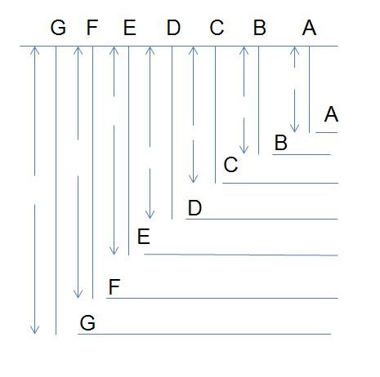

NOTE: A COMMON GROUND ELECTRODE TO THE LIQUID IS REQUIRED IF
VESSEL IS LINED OR NON-METALLIC.

Electrode Material Preference:
Insulation: | Bare | PVC | Teflon
Note: For lengths over 6 feet long, recommend using insulated electrodes.

Electrode Holder Material:
Cast Iron Brass Stainless Steel PVC

Electrode Holder Mounting:
Threaded | Flange | Size:

Distance from Vessel to Available Power:
Power Available:

Electrical Rating of Control Devices:
Horsepower Rating: |  | Or Amperage:

Area Classification: Vessel:
At Controls:

Type of Liquid Level Controls Desired:
Electro Mechanical: |  |  | Solid State
 |  |  | Panel Mount:
 |  |  | Plug-In

Electrical Enclosure Desired:
Open NEMA 1 NEMA 4 NEMA 7 NEMA 12
Are controls to be mounted in:
One Enclosure or Individual Enclosures

Comments:

Recommended Catalog Items:
Prepared by: |  |  | Date:

